Zadanie 6 - Differential Evolution Algorithm

Michał Darowny, 210957

1. Task

The task for this exercise was to prepare Differential Evolution Algorithm implementation as TCP service. To run you need compile and run Main class and then Client class. Graphs are produced using Jzy3D library

1. Methods

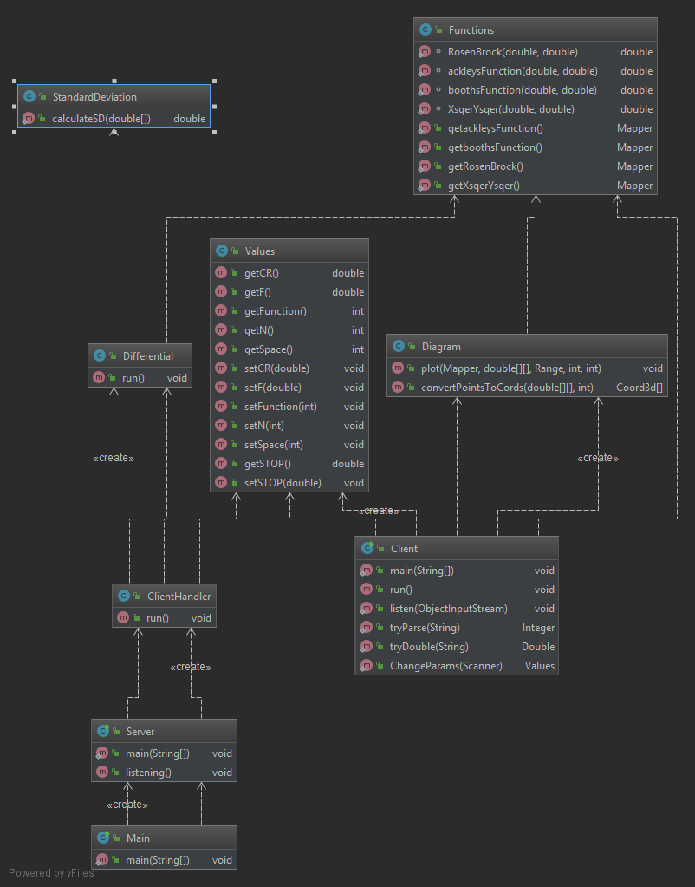

Figure 1. All methods and constructors

Main class creates Server class and starts listening for clients using listening() method , if the new client connects it creates new thread class ClientHandler to listen for requests and which sends responses to the client. To do that client creates Values class with values needed for the algorithm and this class is used for communicating what values and what function should be picked for the optimization. When Client Handler receives request and Values it then starts Differential class which takes in ObjectOutputStream of the socket of the client and performs calculations each important step is send to the client which is listening for responses. After the calculations has been made the Differential sends back the values for the plot as array, then Diagram class plots the function and agents in search space. The more precise Differential way of operation is that is starts population of n agents which each is 2D array to store positions. For each dimension (position x and y) we get random 3 agents from population and each one is different from others. The mutant is the agent which was created from these three random picks we set up its dimensions (position values) as in figure 2 , it is randomized by Crossover coefficient and F is differential weight coefficient.

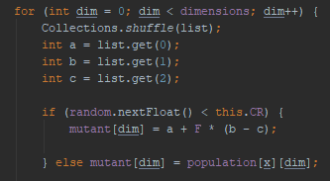

Figure 2. Mutating random agent in population

Then after that we check if position of the mutant returns lower values than the other random agent if so that random agent positions are replaced by mutant’s. The stop condition for algorithm was chosen to be standard deviation of relative position of all agents. So until all agents clump we repeat random picking and mutating . To distinguish between functions for plotting and calculations we use the Functions class. Differential class uses Functions for finding values of agent’s positions and Diagram class uses Functions to create Mapper class from the library Jzy3D to plot function on the graph.

1. **Fields**

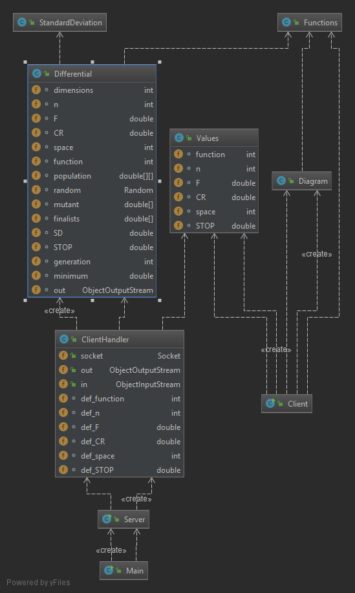

Figure 3. Fields in all classes

Client Handler has default parameters n- population number as well Differential weight and Crossover coefficient and search space size, Differential class dimensions sets up how many dimensions are in optimization, function is used to distinguish the function on which we operate, generation is used to note how many loops we needed to complete before convergence of all agents, minimum is needed so that we know from what value we start the algorithm (Maximal possible values so we do not miss any minima.